2400 N. 32nd St
TENKILLER Muskogee, OK 74401
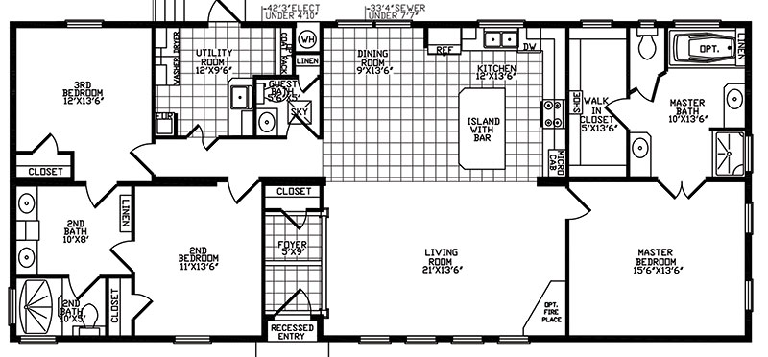
28X60 | 3 bed/2.5bath | 1792 sq. ft. 918-683-7791 | www.homestoreltd.com

